Table of Contents

**A Functional Discussion of IP Phones within a Hierarchical Network Design** 1

**Configuring VoIP Phones using Cisco Packet Tracer** 1

**Topology** 1

**Router Configuration** 1

**Switch Configuration** 2

**Configuring the IP Phones through the Router** 2

**Operational Notes** 2

**IP Phone within a Simple Hierarchical Network Design** 4

**Core Router Configuration** 4

Distribution Multilayer Switch Configuration 4

Access Switches 1-3 Configuration 5

Access Switches 1-2 5

Access Switch 3 6

**Server** 6

**Enterprise VoIP or Telephony Service with Dial Peering** 7

# **A Functional Discussion of IP Phones within a Hierarchical Network Design**

Let’s break down the most critical configuration line in setting up the IP Phone in Cisco Packet Tracer.

**1. option 150 ip 192.168.10.1**

* This is configured under a **DHCP pool**.
* option 150 tells the **IP Phones the TFTP server address** (where they download their phone configuration files).
* In a CME setup, the **TFTP server is the router running telephony-service**.
* Example:
* ip dhcp pool VOICE
* network 192.168.10.0 255.255.255.0
* default-router 192.168.10.1
* option 150 ip 192.168.10.1 ! <-- tells phones “your CME is at 192.168.10.1”

👉 Without this, phones will get an IP but **never find CME** → they’ll stay stuck in “Configuring CM list”.

**2. telephony-service**

* This **enables CME (Call Manager Express)** on the router.
* It creates the **call control server** for SCCP phones.
* Inside this mode, you define how many phones and directory numbers (DNs/extensions) your system supports.

**3. max-dn 5**

* **DN = Directory Number** = basically an **extension number** (like 54001, 54002, etc.).
* This line says: *“The CME can create up to 5 directory numbers.”*
* Think of it as the **number of phone lines** the router will support.

**4. max-ephones 5**

* **ephone = Ethernet Phone** = the actual physical IP Phone.
* This line says: *“Up to 5 phones can register with CME.”*

👉 You need both:

* max-dn = how many extensions.
* max-ephones = how many physical phones.

**5. ip source-address 192.168.10.1 port 2000**

* This tells CME: *“Use the router IP 192.168.10.1 and TCP port 2000 for SCCP communication with phones.”*
* Port 2000 is the **default SCCP signaling port**.
* Without this, even if DHCP Option 150 is correct, phones won’t complete registration.

**6. auto assign 1 to 5**

* This automatically assigns extensions (from the pool of available ephone-dns) to phones as they register.
* So the **first phone that registers** gets DN 1, the next gets DN 2, etc.
* Saves you from manually binding phones to DNs when testing in Packet Tracer.

**7. ephone-dn 1 number 54001**

* Creates the **first Directory Number (DN)** and assigns it the extension **54001**.
* Phones will use this number to **call each other**.
* Example:
* ephone-dn 1
* number 54001
* ephone-dn 2
* number 54002
* If auto-assign is on → the first registered phone will automatically get **54001**, the second will get **54002**, etc.

**✅ Putting It All Together**

* **DHCP + Option 150** → Phones get IP + TFTP server (router).
* **telephony-service with ip source-address** → Router acts as CME server.
* **max-ephones / max-dn** → Defines system capacity.
* **auto assign** → Automatically maps extensions to phones.
* **ephone-dn** → Defines actual phone numbers/extensions.

So, in short:  
👉 Phones boot → get DHCP lease → learn TFTP = 192.168.10.1 → contact CME on 192.168.10.1:2000 → auto-assign binds DN (54001) to phone → you can place calls.

# **Configuring VoIP Phones using Cisco Packet Tracer**

Source: <https://youtu.be/TGMzUDE9XiU?si=7s2dGtEv84wlPsqx>

## **Topology**

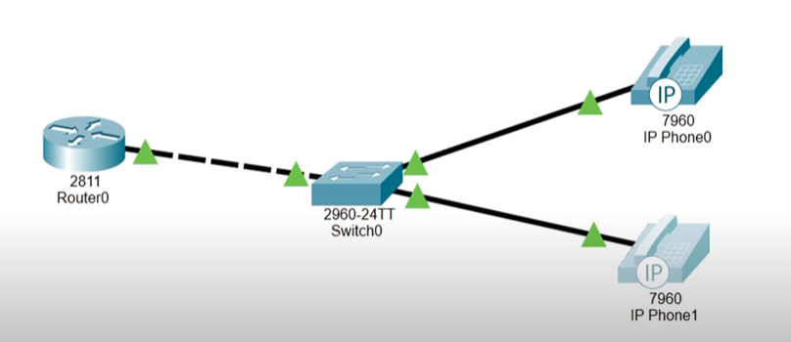

**Router Configuration**

Int fa0/0

Ip add 192.168.10.1 255.255.255.0

No sh

exit

Ip dhcp excluded-address 192.168.10.1

Ip dhcp pool voice_pool

Network 192.168.10.0 255.255.255.0

Default-router 192.168.10.1

Option 150 ip 192.168.10.1

Exit

Telephony-service

Max-dn 5

Max-ephones 5

Ip source-address 192.168.10.1 port 2000

Auto assign 4 to 6

Auto assign 1 to 5

## **Switch Configuration**

Int r fa0/2-3

Switchport mode access

Switchport voice vlan 1

exit

## **Configuring the IP Phones through the Router**

! Connect only one IP Phone first

Ephone-dn 1

Number 54001

Exit

! Connect the other phone

Ephone-dn 2

Number 54002

exit

## **Operational Notes**

* Connect and Configure each IP Phone separately, that is, disconnect the other IP Phone first before configuring the other one.
* In Cisco Packet Tracer, only router 2811 with the legacy CME can be utilized to integrate IP Phones.

# **IP Phone within a Simple Hierarchical Network Design**

## **Core Router Configuration**

Ip routing

Int fa0/0

Ip add 192.168.10.1 255.255.255.252

No sh

exit

telephony-service

max-dn 10

max-ephone 10

ip source-address 192.168.10.1 port 2000

auto assign 1 to 10

exit

ip route 0.0.0.0 0.0.0.0 192.168.10.2

## Distribution Multilayer Switch Configuration

Ip routing

Int g1/0/1

No switchport

Ip add 192.168.10.2 255.255.255.252

No sh

exit

ip route 0.0.0.0 0.0.0.0 192.168.10.1

int vlan 10

description “Staff VLAN”

ip add 10.10.10.1 255.255.255.0

no sh

int vlan 20

description “Administrators VLAN”

ip add 10.10.20.1 255.255.255.0

no sh

int vlan 30

description “Voice VLAN”

ip add 10.10.30.1 255.255.255.0

no sh

int vlan 40

description “Servers VLAN”

ip add 10.10.40.1 255.255.255.0

no sh

vlan 10

name Staff

vlan 20

name Administrators

vlan 30

name Voice

vlan 40

name Servers

int r g1/0/2-4

switchport mode trunk

switchport trunk allowed vlan 10,20,30,40

int vlan 10

ip helper-address 10.10.40.2

int vlan 20

ip helper-address 10.10.40.2

int vlan 30

ip helper-address 10.10.40.2

## Access Switches 1-3 Configuration

vlan 10

name Staff

vlan 20

name Administrators

vlan 30

name Voice

vlan 40

name Servers

int fa0/1

switchport mode trunk

switchport trunk allowed vlan 10,20,30,40

## Access Switches 1-2

int fa0/2

switchport mode access

switchport voice vlan 30

switchport access vlan 20

## Access Switch 3

Int fa0/2

Switchport mode access

Switchport access vlan 40

## **Server**

Ip add 10.10.40.2 255.255.255.0

Default-gateway: 10.10.40.1

Name: Staff_Pool

Network address: 10.10.10.0

Subnet: 255.255.255.0

Default-router: 10.10.10.1

TFTP: 192.168.10.1

Name: Administrators_Pool

Network address: 10.10.20.0

Subnet: 255.255.255.0

Default-router: 10.10.20.1

TFTP: 192.168.10.1

Name: Voice_Pool

Network address: 10.10.30.0

Subnet: 255.255.255.0

Default-router: 10.10.30.1

TFTP: 192.168.10.1

# **Enterprise VoIP or Telephony Service with Dial Peering**